



OAA Model Procurement Documents
Request for Proposal (RFP)
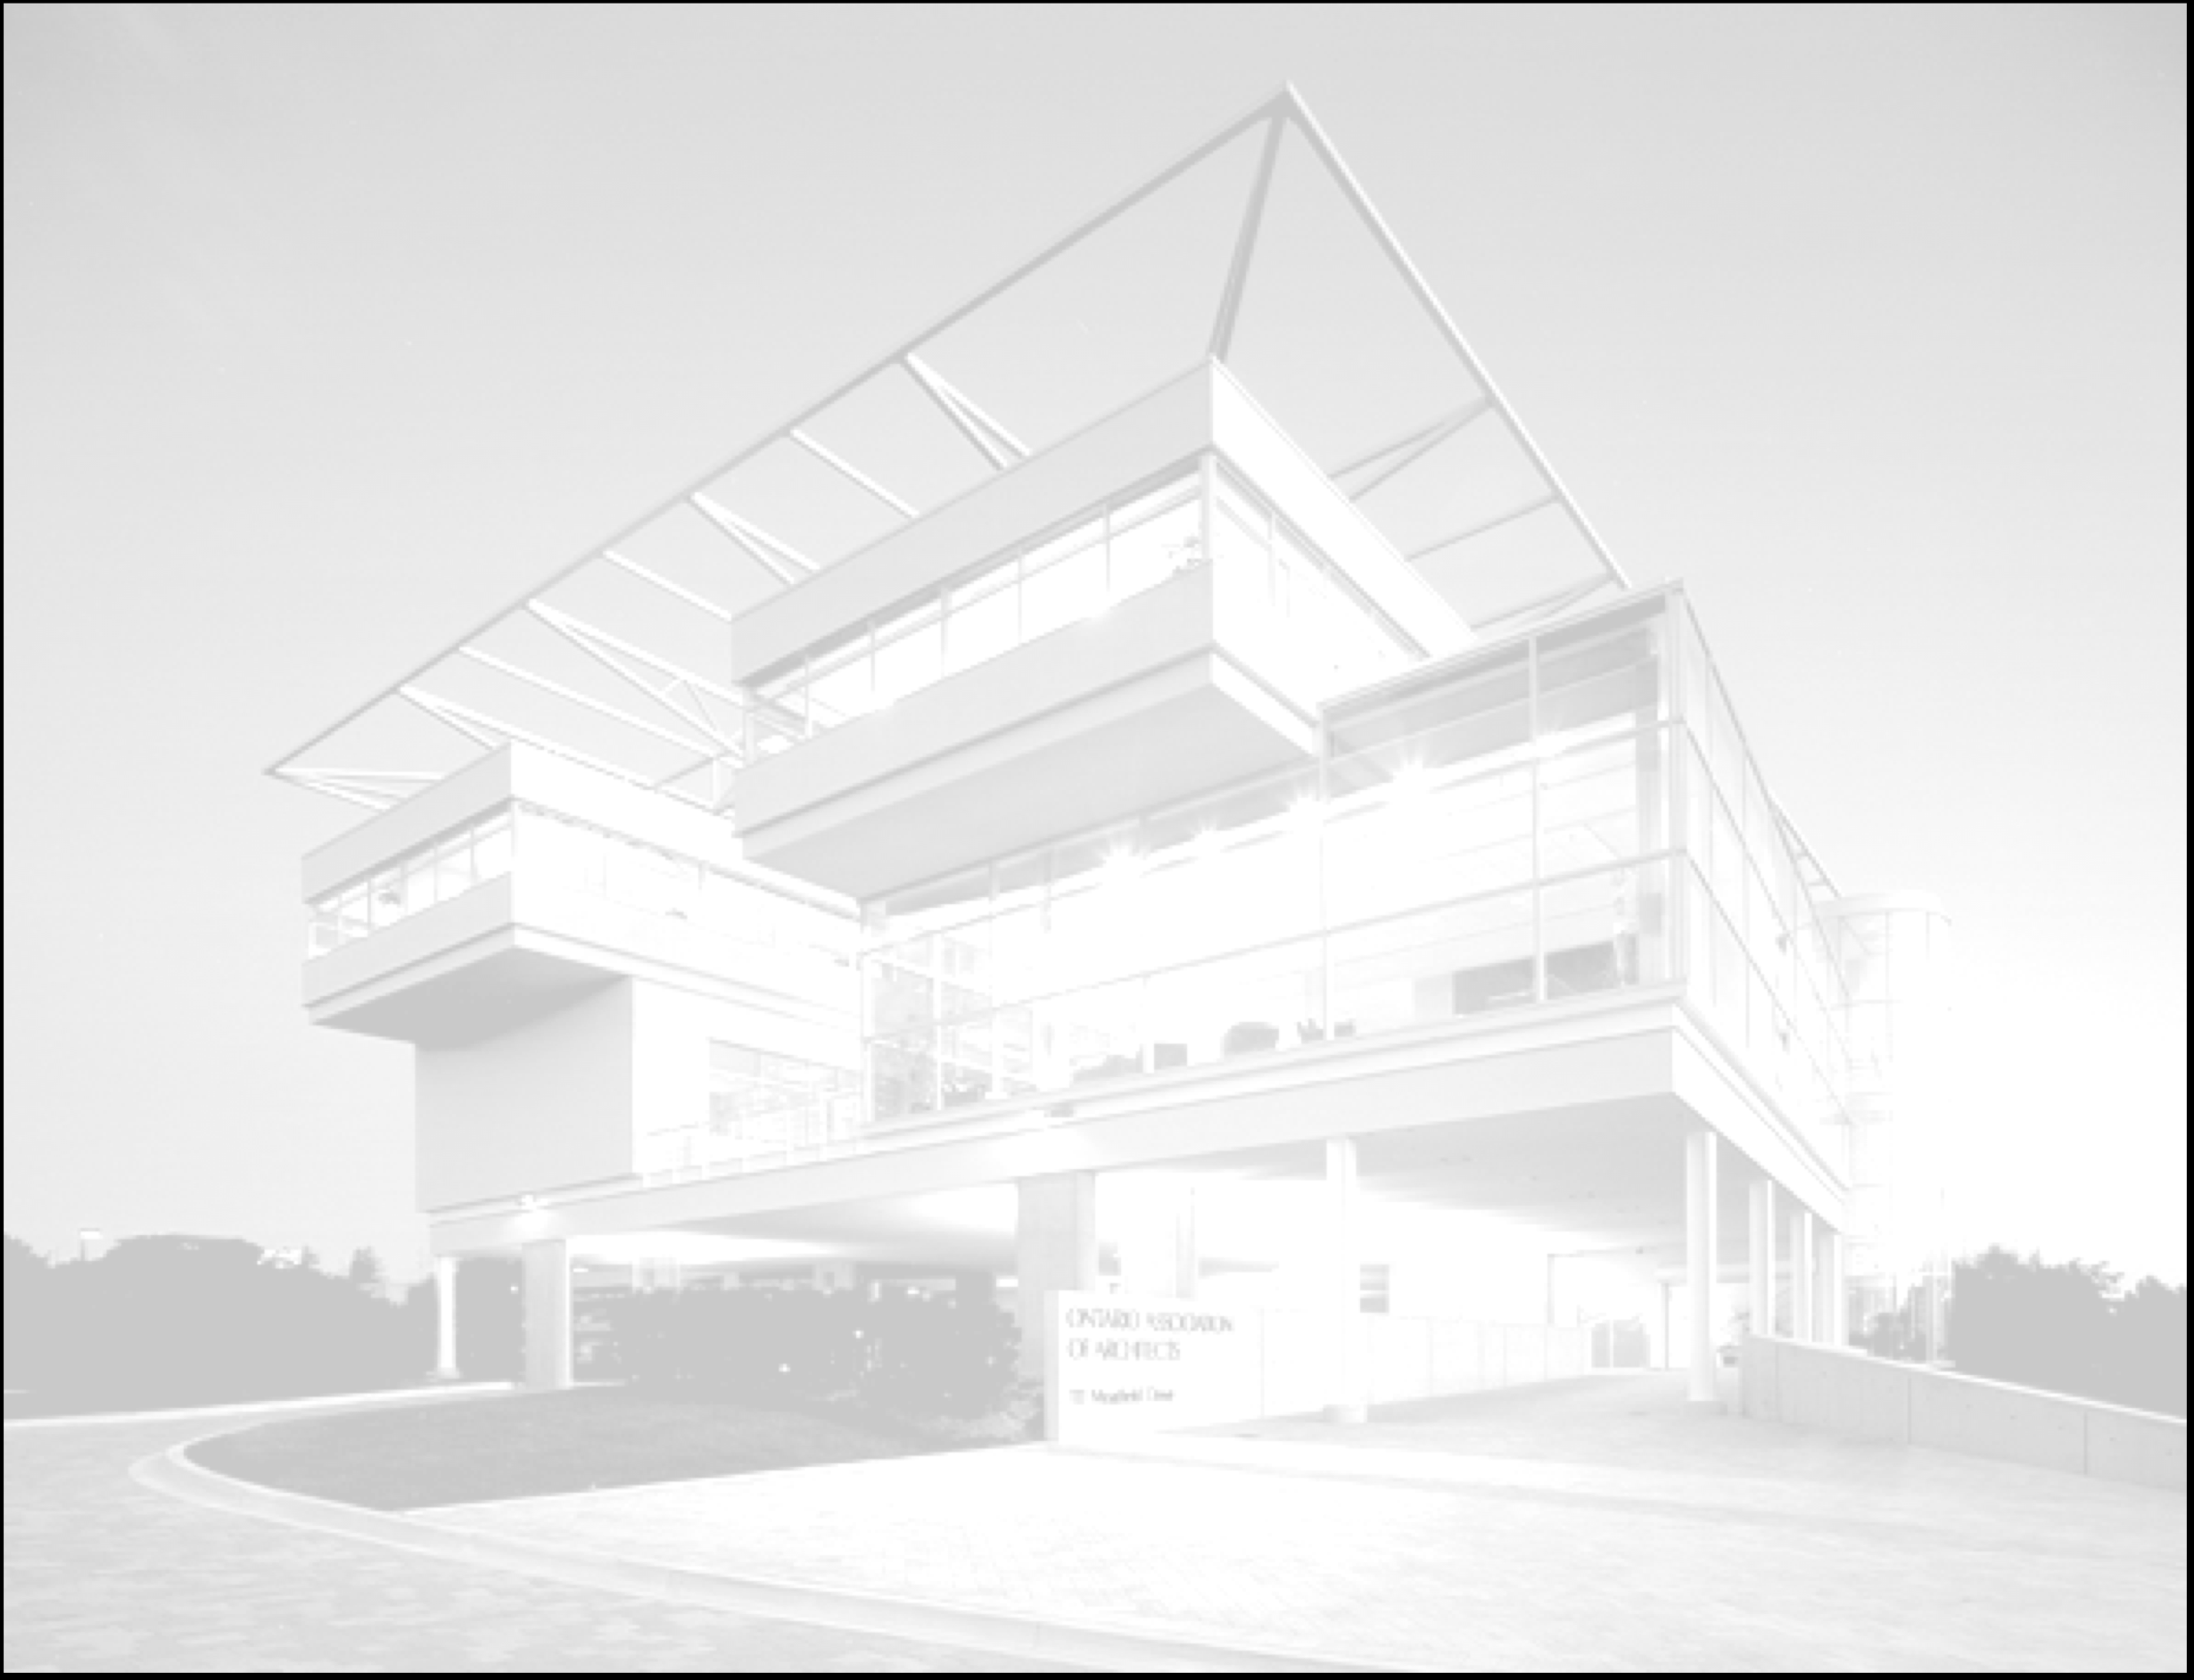

February, 2011

Introduction to the Templates

In order to maintain consistency with the established two stage approach utilized by the federal, provincial and municipal governments of identifying and qualifying Architectural Consultants using a Request for Statement of Qualifications (SofQ) (to establish a list of qualified Architectural Consultants) and then awarding contracts using a Request For Proposal (RFP) for the contract; the package contains two templates, the first for qualifying the potential proponents, the SofQ, and the second for the selection of the final proponent, the RFP, which is designed for the specific project requirement.
Template Key/Conventions
The first convention is the use of red, italicized font. This indicates where Client content must be provided.
The second convention is the use of term “bname”. This term has been utilized to facilitate use of this RFP template by allowing the Client to search for and replace the Client name quickly.

Prepared by the OAA
February, 2011
Client Logo

Request for Proposal

for
Project Name

RFP No. nn

This Request for Proposal Closes at
location: nn:00 p.m. (local timezone time)
on date
Issued: date

Table of Contents

A GENERAL INSTRUCTIONS
A.1 Invitation
A.2 Contracting Authority
A.3 Project Authority
A.4 Terms and Conditions
A.5 Form Of Contract
A.6 Insurance
A.7 Submission Format
A.8 Closing Location, Date and Time
A.9 Security Clearance Requirements (if required)

B PROJECT DESCRIPTION

B.1 Project Background
B.2 Project Budget
B.3 Project Schedule

C SCOPE OF SERVICES

C.1 Project Description and Defined Scope of Work
C.2 Scope of Services
C.3 Contract Delivery Method

D SUBMISSION REQUIREMENTS

D.1 Proposal Requirements
D.2 Understanding of the Requirement
D.3 Consultant Team
D.4 Approach and methodology
D.5 Project Plan and Schedule
D.6 Overall Quality of Proposal

E EVALUATION PROCESS

E.1 Technical Evaluation of Proposals

E.2 Evaluation Committee

E.3 Evaluation Criteria Table

E.4 Evaluation Process
E.5 Interview
E.6 References

APPENDIX A – RFP Submission Form

A GENERAL INSTRUCTIONS

Invitation
bname is inviting prequalified proponents to make proposals for nn services.
The purpose of the RFP is to enable bname to identify the Proponent that achieves the xx (highest etc.) score to carry out the work.
This RFP is the second phase of a two-phase procurement process, the first phase of which was the Request for Statement of Qualifications (SofQ) phase during which Proponents were qualified. These prequalified proponents are now invited to submit technical proposals for the work.
This Request for Proposal (RFP) document sets out the requirements for the Proponent’s proposal and specifies the evaluation criteria and Consultant selection process for this phase. Consultants must be able to demonstrate a thorough understanding of the requirement, provide their approach and methodology, project plan and schedule.

Contracting Authority
The Contracting Authority for this Request for Proposal is:
Contact name
Address

Project Authority
The Project Authority for this Request for Proposal is:
Contact name
Address

Terms and Conditions

Glossary of Terms
Proponent: The prime Consultant entity who submits a proposal. The entity that will execute the contract with bname and will have full contractual responsibility for the delivery of the required services
Consultant Team: The prime Consultant and its team of architects, engineers, Key Personnel, sub-consultants, as applicable who are proposed for the services required.
Key Personnel: Key Personnel are the critical management and senior resources that carry the responsibility for project delivery. They are individuals that will have a direct and substantial involvement in the work and whose roles and responsibilities will be crucial to the successful completion of the project.
Request for Statement of Qualifications: bname’s initial solicitation document setting out the rules, procedures and qualification requirements for the prequalification stage.
Request for Proposal: the second stage procurement open to prequalified consultants to compete for the contract.
  - Mandatory and Advisory Clauses
Mandatory clauses during the procurement are those containing the word “must”, “will” or “shall”. These clauses must be observed at all times, unless otherwise authorized by bname. Proponents not respecting these clauses will be disqualified and their proposals will not receive any further consideration. Advisory clauses during the procurement are those containing the word “may” or “should”. Proponents not respecting these clauses may be scored lower.

Licencing Requirements
The Proponent assumes responsibility for compliance with all laws and regulations concerning its eligibility to provide a Submission and to perform the Services in the Province of Ontario and is aware that this RFP is governed by the laws of the Province of Ontario.
Proponents are required to hold a valid Certificate of Practice (CofP) from the OAA.
To verify OAA Licence and CofP status, contact the OAA registrar or check the OAA web site at www.OAA.on.ca.
By virtue of making a submission:
The Proponent certifies that the Proponent has satisfied itself that it is in compliance with the requirements of Item A.4.3.
The Proponent acknowledges that bname has the right to verify any information in respect of Item A.4.3. after contract award and that false, erroneous, or inadequate certification may require that the Proponent provide substitute personnel, at the Proponent’s own expense, for the approval of bname.

Integrity of Consultant Team Key Personnel Maintained
Proponents are advised that the Key Personnel named in the SofQ submission shall remain in their designated roles throughout the RFP period and for the duration of the project.
If the Key Personnel named in a Proponent’s proposal leave or become unavailable or unable to perform their duties for circumstances beyond the Proponent’s reasonable control, the Proponent shall promptly notify the Contract Officer and submit resumes of proposed replacement personnel. Proposed replacement personnel should possess professional and/or technical qualifications and comparable experience equivalent to the Key Personnel being replaced.
Should any of the Proponent’s replacement personnel be considered in any respect unsatisfactory, alternative replacement personnel shall be proposed by the Proponent within n (n) days of receipt of the notice of dissatisfaction from bname.
No payment shall be made for fees incurred by Consultant Team members who were not approved by bname prior to work taking place.
Failure to honour these requirements may result in rejection of the proposal.

Queries During the RFP
The Proponent will base their proposal on the bname RFP documents. It is the responsibility of the Proponent to obtain clarification of any terms, conditions or technical requirements contained in the RFP.
Any questions or requests for clarification during the solicitation period must be submitted in writing by the primary contact of the Proponent to the Contracting Officer identified on the front page of this RFP document. Inquiries relating to this solicitation are to be directed ONLY to the Contracting Officer. Non-compliance with this condition during the solicitation period may, for that reason alone, result in the disqualification of the Proponent.
Questions and requests for clarifications will be answered if received in writing by the Contracting Authority at least n (n) calendar days prior to the date stipulated for making the proposal.
bname will only respond to the prime contact of the Proponent, who will be responsible for further internal distribution as required.

Amendments to the RFP
The answer to all questions or requests will be responded to by an addendum which will be issued to all Proponents.
Proponents are advised that only the written information issued by bname in this RFP document, and any appended documents and any associated Amendments shall be contractually binding.

Right to Initiate or to Terminate Negotiations
bname shall have the sole right to initiate or to terminate negotiations.

Right to Request Clarifications / Confirmations
bname reserves the right to request clarifications and/or confirmations from any or all Proponents regarding any aspect of the proposal. In the event such clarifications and/or confirmations are requested, the Contracting Officer will make the request. The request for clarification and/or confirmation will be directed to the individual named as the Proponent’s contact in their proposal. A written response to each such communication is required from the Proponent.

Payment for Proposal
There will be no direct payment by bname for the document preparation and submission in response to this RFP.

Privacy and Access Legislation
Proponents are advised that bname is subject to the provisions of all applicable privacy and access to information legislation. Information submitted may be eligible for disclosure in accordance with the corresponding legislation. Information is not released without consultation with the Proponents, unless there is an order made under the applicable act.

Debriefing
A debriefing will be provided to Proponents that are not successful in this competition, if requested in writing to the Contracting Officer within nn days of the notification. The debriefing will include an outline of the reasons the proposal was not successful, making reference to the evaluation criteria. The confidentiality of information relating to all other proposals will be protected. Debriefing elements will include identification of the strengths and weaknesses of the proposal along with the overall and individual requirement scores. It will not include any information about other proposals.
bname will, however, destroy all unsuccessful proposals nn days after the notification of the result unless the Proponent in question has requested in writing a debriefing or the return of the proposal to the Proponent’s office at the Proponent’s cost.

Order of Precedence of Documents
In the event of conflicts between the documents, the following will be the order of precedence:
- RFP (and amendments).
- SofQ (and amendments).

Copyright and Use of Documents
bname will be guided by the Royal Architectural Institute of Canada’s Practice Builder titled Electronic Documents which sets out the parameters for copyright and use of documents.

Selection of Successful Proponent
During the RFP phase of this procurement the basis of selection will be a technical proposal.

Financial Letter of Good Standing
The Proponent must provide a Letter of Good Standing from the Proponent’s financial institution.

Client to decide if this is required dependant on the scale / scope of the project.

Form of Contract (Ontario)
The Ontario Association of Architects Standard Form of Contract for Architect’s Services, DOCUMENT 600, (current version) will be used as the contract template. It is available at: www.oaa.on.ca/client/oaa/OAAHome.nsf/web/Document+600?OpenDocument

Insurance
The proponent agrees to purchase and maintain in force for the duration of this Agreement, the following policies of insurance:
- Professional Liability Insurance:
Holders of certificates of practice or temporary licences (Proponent) unless exempted, are required by the Architects Act and its regulations to be insured for errors and omissions arising out of the performance or non-performance of architectural services under a professional liability policy through Pro-Demnity Insurance Company with a minimum liability limit of not less than $250,000 for each claim, and $500,000 in the annual aggregate in respect of any one project.
Holders of certificates of practice and temporary licences (Proponent) exempted by the regulations must purchase and maintain in force professional liability insurance from other insurance companies for similar limits.
Should the client wish to increase the amount of insurance that the proponent currently carries or obtain special insurance coverage, then the proponent shall cooperate with the client to obtain such increased amount or special insurance at the client’s expense, at such time as the identity of the successful proponent is determined.
- Commercial General Liability Insurance:
Liability Limit required $_______________.
The insurance shall include but not be limited to the following:
Commercial general liability form IBC 2100 or as amended, with
i) The client added as an additional insured;
ii) Provision for cross liability and severability of interest as between the proponent and the client:
iii) Be insured with an insurance company licensed in the Province of Ontario;
iv) Not less than thirty (30) days’ prior written notice to the client of cancellation or termination of insurance, reduction of liability limits, or revision of coverage.
v) Automobile liability coverage in the amount of not less than $__________.

Submission Format

Number of Copies
n (n) complete copies of the Proponent’s proposal are to be provided. Each copy of the Proponent’s proposal must include a completed and signed copy of Appendix A of this RFP document.

Proposal Signature Requirements
The Proponent’s proposal is to be signed by the firm’s signing authority.

Proposal Format
Documents must be formatted as follows:
- Paper size - 8.5" x 11" (metric equivalent A4) OR as indicated. A 11X17 page may be used to present a plan or schedule. Each 11X17 page will be counted as one page.
- Point size - 11 point ARIAL or equal
- Margins - 25mm (1") left, 19mm (3/4") top, 12mm (1/2") right and bottom
Double-sided pages will be counted as two (2) pages
The Proposal cover, letter of introduction and tab dividers will not be counted.
Appendix A may be reproduced by Proponents in their own format provided that the order of the items and content remains unchanged.
Proposals will be evaluated solely on the contents of the material as requested in this RFP. Supplementary material in the form of company brochures etc., if submitted, will not be forwarded to evaluators.
Proposals exceeding the page counts will be considered as non-compliant and will be disqualified. Refer to E.3 for maximum number of pages.

Closing Location, Date and Time

Closing Location
Hardcopy proposals shall be received at the following location. Faxed or e-mailed proposals will NOT be accepted. Location to be provided.

Closing Date and Time
Proposals shall be received at the closing location by date and time.

Late Proposals
It is the responsibility of Proponents to allow sufficient time to ensure delivery of their proposals to the designated location prior to the stipulated closing time and date. Late proposals will not be accepted.

Security Clearance Requirements
Describe if required.

B PROJECT DESCRIPTION

Project Background
This architectural project is to design…….
Describe the project background and description of requirements in broad terms, also the building type, etc.

Project Budget
The budget (excluding soft costs) for this project is in the order of $n.
This amount excludes all taxes.
(Provide a detailed break-down of the costs).

- Project Schedule
The following major milestones are anticipated for the delivery of this project:
This will be project specific; it should not be a detailed schedule in the RFP). If there are project specific target dates that must be met (due to funding source) this should be stated.
Milestone Date / Duration
- Consultant Selection
- Architectural Design Phase
- Tender Contract Documents
- Award Construction Contract
- Construction Start
- Construction Completion

C SCOPE OF SERVICES TO BE PROVIDED

Project Description and Defined Scope of Services
The required services are as follows: describe the project at a detailed level including a detailed description of the services, required deliverables, etc.

Client to provide a detailed outline of the services required, topics to cover (as required):

General services required

Project Scope

Project Phasing / Staging (if applicable)

Project Planning

Design Phase

Construction Phase

Project Demarcations

Project Control and reporting

Documentation Protocols

Services to be provided by others

Critical Success factors

- Scope of Services – RAIC Checklist
The required work includes the services detailed on the following Royal Architectural Institute of Canada's (RAIC) “Checklist: Scope of Services”. Note that the services with the solid black bullets are Basic Services. Services with the clear bullets are Additional Services. Additional required services should be marked with an “X”.

- Contract Delivery Method
Type of contract delivery method anticipated for construction of the project, (lump sum, construction management).

Any specific client requirements should be mentioned here.

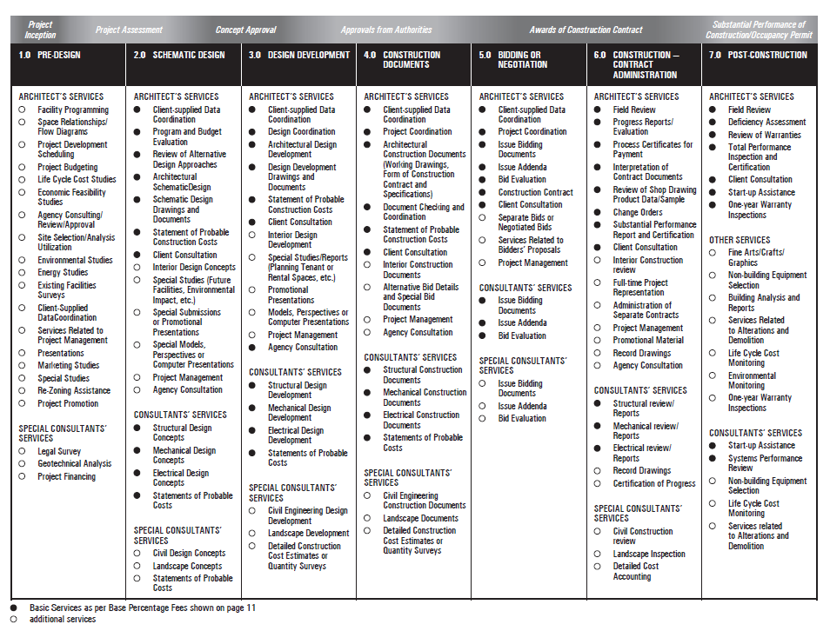
C.2 Scope of Services - RIAC Checklist:

D SUBMISSION REQUIREMENTS

Proposal Requirements
Proponents’ proposals are to be based solely on the criteria described below and any Amendments/Addenda issued thereto. Proponents are advised to present the requested information clearly and concisely. The information should be relevant and given in context to this particular project. For the convenience of evaluators, the proposal must be ordered to coincide with the proposal criteria specified herein. Failure to provide the requested information may result in rejection of the proposal.
Evaluations will be based on the criteria identified in the balance of this section.

Understanding of the Requirement
Proponents must describe their understanding of the requirements including a discussion of the challenges and associated resolutions. (Maximum n pages)

Consultant Team
Proponents must refer to Section A.4.4 Integrity of Consultant Key Personnel Team Maintained. In the event that the proposed Key Personnel are no longer available at the time of proposal submission, the Proponent must submit as part of their proposal, a new response to the SofQ Consultant Team requirement in its entirety..

Approach and Methodology
Approach
Through a discussion of the unique aspects, procedures, benefits, skills and techniques that the Consultant’s Team will bring to this project, demonstrate your understanding (as provided under section D.2) of the processes that will be applied to the successful delivery of this project. Explain the Proponent’s proposed approach and methodology to satisfy project requirements. (Maximum n pages)
Communication and Issue Resolution Strategies
Describe the Consultant Team’s reporting structure and proposed communications strategies, both within the Team and with bname. Describe reports and other deliverables that will be used to manage the work. Describe the Proponent’s approach to conflict resolution and processes that will be used to resolve issues during project delivery. (Maximum n pages)
Quality Assurance / Quality Control (QA/QC)
Proponents must demonstrate their commitment to achieving quality as it applies to both the design and construction of the project. Proponents are to describe their quality control procedures and the methods proposed for quality assurance. (Maximum n pages)
Proposed Schedule and Cost Control Procedures
Proponents are to discuss their scheduling strategy and any innovative, proactive measures their team will adopt to address the project timelines. Highlight any areas to which the Proponent will pay particular attention given understanding of the project scope. Outline the roles and responsibilities of team members in the schedule control process. (Maximum n pages)

Project Plan and Schedule
Provide a detailed project plan including all activities, milestones and dates and provide a narrative work breakdown structure.

Overall Quality of Proposal
Proposals will be evaluated for quality, presentation and conformance to the prescribed format.

E EVALUATION PROCESS

Technical Evaluation of Proposals
Proposals will be evaluated by individuals employed by bname. The evaluation process will involve the review and scoring of the information provided in the proposal against the criteria specified in Items D.2 to D.5 inclusive. The proposal will be evaluated out of n points.
- Evaluation Committee
An Evaluation Committee will be convened by bname and at least two members will be Architects and Engineers. All members of the Evaluation Committee will have equal votes in the evaluation process. A matrix will be used to compare the scores of each evaluator, and a consensus will then be reached through discussion internal to the Committee.
- Evaluation Criteria Table
Evaluation Criteria | Max/Min Points | Max #  pages
Understanding of the Requirement | nn/nn
Consultant Team | nn/nn
Approach and Methodology | nn/nn
Project Plan and Schedule | nn/nn
Overall Quality of Proposal | nn/nn
SofQ percentage score (15%) | nn
Interview (if applicable) | nn/nn
Total Score | nn/nn

- Evaluation Process
Proponents must achieve a minimum overall score of n %.
Proposals which do not achieve the minimum scores per Item E.3. will receive no further consideration.
The Proponent achieving the highest overall score in the evaluation will be invited to negotiate a contract with the client.

Professional Fees should be based on the RAIC (Royal Architectural Institute of Canada) document titled “A Guide to Determining Appropriate Fees for the Services of an Architect”.

In the event that any of the n (n) invited Proponents, per Item E.3., declines the invitation to participate further in the RFP phase, bname reserves the right to invite the next highest scoring Proponent to participate in the RFP phase of this competition.
- Interview
bname reserves the right to schedule interviews with the n highest ranking Proponents as a final RFP evaluation element. Pursuant to evaluation of the Technical Proposals, and at the sole discretion of bname, some or all of the Proponents may be invited to attend an interview with bname. The selected Proponents will first be given 30 minutes to make a presentation to amplify their Technical Proposal. Following a short recess, there will a 30 minute interactive session during which the Evaluation Committee members will present a series of questions, some of which will be common to all Proponents, while others will be specific to each Proponent. At the conclusion of each interview the Evaluation Committee will assess the interview with respect to focus, clarity, organization, team chemistry and overall impact and thereby assign a consensus score of up to nn points. Administrative arrangements for the interview are as follows:
Interviews will be scheduled within one week following the submission of Technical proposals.
Time slots will be assigned by means of random selection.
Each Proponent will be allowed a maximum of 3 to 6 participants at the interview.
Client to decide max. # of participants at interview.
When notified of the interview schedule, Proponents will be asked to name the participants in advance.
Proponents will be given 30 minutes set up time before the interview and will be provided with a screen and an LCD projector (if required).

- References
bname reserves the right to contact any or all project references indicated in the Proponent’s submission and to use this information in the evaluation and scoring of submissions.

Appendix A
Request for Proposal
Submission Form
Date:

Submitted By: ____________________________________________________ “Proponent”

To: NNN
NNN Address

- The undersigned acknowledges receipt of the addenda listed hereafter:

Addenda No. Date of Issue
___________ ____________
___________ ____________

- Pursuant to and in compliance with the RFP Documents and the addenda listed above, the undersigned, being familiar with the RFP Documents, and all relevant laws, rules, notices, directives, standards, orders and regulations, licensing and permit requirements, labour markets and other circumstances which may affect its submission, hereby submit a proposal to provide Design and Engineering services for bname as specified for this project.

- The Proponent declares:
- that it has complied with the instructions;
- that it accepts all of the terms, provisions, stipulations and requirements set out in the RFP;
- that it is not relying on any information other than that set out in the RFP and addenda and SofQ and addenda issued pursuant thereto by the bname;
- that all statements and information set out in its RFP Submission Form or otherwise provided to bname in connection with the RFP, including statements and information hereafter provided, are and will be true, accurate and complete, not misleading and in accordance with the principles of full, true and plain disclosure.

- Where a Proponent is comprised of more than one entity, all entities comprising the Proponent shall be jointly and severally liable.

The undersigned has completed this RFP Submission Form.

Signature of Proponent:

_____________________________ _______________________
Printed Name and Position Signature

_____________________________
Date

