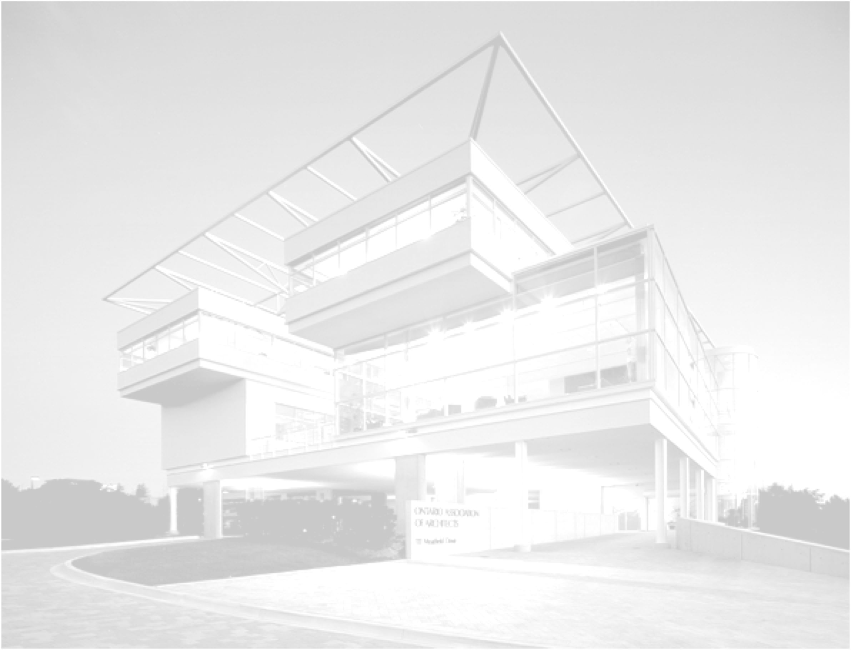


February, 2011





OAA Model Procurement Documents
Statement of Qualification (SofQ)
Introduction to the Templates
In order to maintain consistency with the established two stage approach utilized by the federal, provincial and municipal governments of identifying and qualifying Architectural Consultants using a Request for Statement of Qualifications (SofQ) (to establish a list of qualified Architectural Consultants) and then awarding contracts using a Request For Proposal (RFP) for the contract; the package contains two templates, the first for qualifying the potential proponents, the SofQ, and the second for the selection of the final proponent, the RFP, which is designed for the specific project requirement.

Template Key/Conventions

The first convention is the use of red, italicized font. This indicates where Client content must be provided.

The second convention is the use of term “bname”. This term has been utilized to facilitate use of this SofQ template by allowing the Client to search for and replace the Client name quickly.

Prepared by the OAA

February, 2011
Client Logo

Statement of Qualification

for

Project Name

S of Q No. nn

This Request for Statement of Qualification Closes at
location: nn:00 p.m. (local timezone time)
on date
Issued: date

Table of Contents

A GENERAL INSTRUCTIONS
A.1 Invitation
A.2 Contracting Authority
A.3 Project Authority
A.4 Number of Prequalified Proponents
A.5 Terms and Conditions
A.6 Submission Format Guidelines
A.7 Closing Location, Date and Time
A.8 Security Clearance Requirements (if required)
A.9 Request for Proposal (RFP) Phase

B PROJECT DESCRIPTION

B.1 Project Description
B.2 Project Budget
B.3 Project Schedule

C SCOPE OF SERVICES

C.1 Services to be Provided
C.2 Contract Delivery Method

D SUBMISSION REQUIREMENTS

D.1 Submission Requirements
D.2 Corporate Profile
D.3 Consultant Team
D.4 Resumes
D.5 Reference Projects
D.6 Overall Quality of Proposal

E EVALUATION PROCESS

E.1 Evaluation of Submissions

E.2 Evaluation Committee

E.3 Evaluation Criteria Table

E.4 Evaluation Process

APPENDIX A – SofQ Submission Form

A GENERAL INSTRUCTIONS

Invitation
bname is inviting Consultants to pre-qualify for the design of nn. This Request for Statement of Qualifications (SofQ) document sets out the requirements for the Proponent’s submission of their Statement of Qualifications and specifies the evaluation criteria and Consultant selection process for this phase.
The purpose of the pre-qualification process is to enable bname to identify and invite the n (n) Proponents who achieve the highest Total Score in the pre-qualification phase to participate in the second phase of this competition.
This pre-qualification process is the first phase of a two-phase procurement process. The second phase is the Request for Proposal (RFP) phase. During the RFP Phase, the pre-qualified Proponents will be invited to prepare and to submit a technical proposal for this work.
The Consultant and its personnel will be evaluated on the basis of their key personnel and the quality of their relevant experience, as appropriate for the size and type of proposed project. Consultants should be able to demonstrate successful delivery of design services for a variety of projects.

Contracting Authority
The Contracting Authority for this Request for Statement of Qualifications is:
Bname + Contact Name
Address + Phone # + e-mail

Project Authority
A Project Authority will be identified at time of RFP issuance. The Project Authority will be responsible for all matters concerning the technical content of the work under the contract.

Number of Prequalified Proponents
The number of prequalified proponents will be 3-5. Client to determine quantity.

Terms and Conditions

Glossary of Terms
Proponent: The prime Consultant entity who submits a proposal. The entity that will execute the contract with bname and will have full contractual responsibility and liability for the delivery of the required services.
Consultant Team: The prime Consultant and his/her team of architects, engineers, Key Personnel, and sub-consultants, as applicable who are proposed for the services required.
Key Personnel: Key Personnel are the management and senior resources that carry the responsibility for project delivery. They are individuals that will have a direct and substantial involvement in the work and whose roles and responsibilities will directly influence the successful completion of the project.
Request for Statement of Qualifications: bname’s initial solicitation document setting out the rules, procedures and qualification requirements for the prequalification stage.
Request for Proposals: the second stage procurement that is only open to the consultants shortlisted under the SofQ phase.

Mandatory and Advisory Clauses
Mandatory clauses during the procurement are those containing the word “must”, “will” or “shall”. These clauses must be observed at all times, unless otherwise authorized by bname. Proponents not respecting these clauses will be disqualified and their submissions will not receive any further consideration. Advisory clauses during the procurement are those containing the word “may” or “should”. Proponents not respecting these clauses may be scored lower.

Licencing Requirements
The respondent assumes responsibility for compliance with all laws and regulations concerning its eligibility to provide a Submission and to perform the Services in the Province of Ontario and is aware that this SofQ is governed by the laws of the Province of Ontario.
Proponents are required to hold a valid Certificate of Practice (CofP) from the OAA.
To verify OAA Licence and CofP status, contact the OAA Registrar or check the OAA web site at www.OAA.on.ca. By virtue of making a submission:
The Proponent certifies that the Proponent has satisfied itself that it is in compliance with the requirements of Item A.5.3.
The Proponent acknowledges that bname has the right to verify any information in respect of Item A.5.3 after award and that false, erroneous, or inadequate certification may require that the Consultant provide substitute personnel, at the Consultant’s own expense, for the approval of bname.

Integrity of Consultant Team Key Personnel Maintained
Proponents are advised that the Consultant Team and the Key Personnel named in the SofQ submission shall remain in their designated roles throughout the subsequent RFP period and for the duration of the project.
If the Key Personnel named in a Proponent’s proposal leave or become unavailable or unable to perform their duties for reasons beyond the Proponent’s reasonable control, the Proponent shall promptly notify the Contract Officer and submit resumes of proposed replacement personnel. Proposed replacement personnel should possess professional and/or technical qualifications and comparable experience equivalent to the Key Personnel being replaced.

Queries During the SofQ
The Proponent will base their submission on the SofQ documents. It is the responsibility of the Proponent to obtain clarification of any terms, conditions or technical requirements contained in the SofQ.
Any questions or requests for clarification during the solicitation period must be submitted in writing by the primary contact of the Proponent to the Contracting Officer identified in A.2 of this SofQ document. Inquiries relating to this solicitation are to be directed ONLY to the Contracting Officer. Non-compliance with this condition during the solicitation period may, for that reason alone, result in the disqualification of the Proponent.
Questions and requests for clarifications will be answered if received in writing by the Contracting Authority at least n (n) calendar days prior to the date stipulated for making the submission.
bname will only respond to the prime contact of the Proponent, who will be responsible for further internal distribution as required.

Amendments to the SofQ
The answer to all questions or requests will be responded to by an addendum which will be issued to all Proponents.
Proponents are advised that only the written information issued by bname in this SofQ document, and any appended documents and associated Amendments shall be contractually binding.

Right to Request Clarifications / Confirmations
bname reserves the right to request clarifications and/or confirmations from any or all Proponents regarding any aspect of the submission. In the event such clarifications and/or confirmations are requested, the Contracting Officer will make the request. The request for clarification and/or confirmation will be directed to the individual named as the Proponent’s contact in their submission. A written response to each such communication is required from the Proponent.

Payment for Submission
There will be no direct payment for the document preparation and submission in response to this SofQ.

Privacy and Access Legislation
Proponents are advised that bname is subject to the provisions of all applicable privacy and access to information legislation. Information submitted may be eligible for disclosure in accordance with the corresponding legislation. Information is not released without consultation with the Proponents, unless there is an order made under the applicable act.

Debriefing
A debriefing will be provided to Proponents that do not succeed in being shortlisted to the RFP stage of this competition if requested in writing to the Contracting Officer within nn days of the notification of the shortlist. The debriefing will include an outline of the reasons the submission was not successful, making reference to the evaluation criteria. The confidentiality of information relating to all other submissions will be protected. Debriefing elements will include identification of the strengths and weaknesses of the proposal along with the overall and individual requirement scores. It will not include any information about other proposals.
bname will, however, destroy all unsuccessful submissions nn days after the notification of the shortlist unless the Proponent in question has requested in writing a debriefing or the return of the submission to the Proponent’s office at the Proponent’s cost.

Order of Precedence of Documents
In the event of conflicts between the documents, the following will be the order of precedence: SofQ (and amendments).

References
bname reserves the right to contact any or all references indicated in the Proponent’s submission and to use this information in the evaluation and scoring of submissions.

Submission Format Guidelines

Contents
The Proponent’s submission is to include the following:
- Consultant Team
- Reference Projects
To facilitate evaluation, Proponents are requested to structure their submission according to the sequence of evaluation criteria as outlined in the evaluation criteria contained in Section E.
A Table of Contents must be included at the front of the submission that outlines all components of the submission, including appendices and attachments. The completed Submission Form (Appendix A) must be inserted directly behind the Table of Contents.

Number of Copies
n (n) complete copies of the Proponent’s submission are to be provided.

Submission Signature Requirements
The Proponent’s proposal is to be signed by the company signing authority.

Submission Format Guidelines
Documents must be formatted as follows:
- paper size: 8.5" x 11" (metric equivalent A4) OR as indicated.
- point size - 11 point ARIAL or equal
- margins - 25mm (1") left, 19mm (3/4") top, 12mm (1/2") right and bottom
Double-sided pages will count as two (2) pages
The Proposal cover, Table of Contents and tabs will not be counted.
The Submission Document (Appendix A) may be reproduced by Proponents in their own format provided that the order of the items remains unchanged.
Submissions will be evaluated solely on the contents of the material as requested in this SofQ. Supplementary material in the form of company brochures etc., if submitted, will not be forwarded to evaluators.
Submissions exceeding the page counts will be considered as non-compliant and will be disqualified.

Closing Location, Date and Time

Closing Location
Hardcopy submissions shall be received at the following location. Faxed or e-mailed submissions will NOT be accepted. Location to be provided.

Closing Date and Time
Submissions shall be received at the closing location before date and time.

Late Submissions
It is the responsibility of Proponents to allow sufficient time to ensure delivery of their submissions to the designated location prior to the stipulated closing time and date. Late submissions will not be accepted.

Security Clearance Requirements
Describe if required.

Request for Proposal (RFP) Phase

Selection of Successful Consultant
During the RFP phase of this procurement, the basis of selection will be a technical submission by the Consultant.

Financial Letter of Good Standing
At the RFP stage, bname will require a Letter of Good Standing from the Proponent’s financial institution.
Client should decide if this is required, dependant on the scale / scope of the project, not necessary for small projects.
B PROJECT DESCRIPTION

Project Background
This architectural project is to design…….
Describe the project background and description of requirements in broad terms, also the building type, etc.

Project Budget
The cost estimate (excluding soft costs) for this project is in the order of $n.
This amount excludes all taxes.

Project Schedule
The following major milestones are anticipated for the delivery of this project:
This will be project specific; it should not be a detailed schedule in the SoQ. If there are project specific target dates that must be met (due to funding source) this should be stated.
Milestone Date / Duration
- Consultant Selection
- Architectural Design Phase
- Tender Contract Documents
- Award Construction Contract
- Construction Start
- Construction Completion

C SCOPE OF SERVICES

Services Required

Client to provide a broad outline of the services required, topics to cover (as required):

General services required

Project Scope

Design

Construction

Contract Delivery Method
Type of contract delivery method anticipated for construction of the project, (lump sum, construction management).

Any specific client requirements should be mentioned here.

D SUBMISSION REQUIREMENTS

Submission Requirements
Proponents’ submissions are to be based solely on the criteria described below and any Amendments/Addenda issued thereto. Proponents are advised to present the requested information clearly and concisely. The information should be relevant and given in context to this particular project. For the convenience of evaluators, the submission should be ordered to coincide with the submission criteria specified herein. Failure to provide the requested information may result in rejection of the submission.
Evaluations will be based on the criteria identified in Items D.2 to D.6 inclusive.

Firm Profile
Provide a brief Profile of primary Consultant team’s firm.

Consultant Team
Organization of Consultant Team
Provide an Organizational Chart showing the completeness of the Consultant Team. Indicate the team's organization (the Proponent and the sub-consultant member firms and their areas of responsibility, plus their Key Personnel and specific roles), the reporting structure and lines of communication. (Maximum 1 page), 11” x 17” folded will count as one page.
Name the Proponent’s Key Personnel, including the designated project manager, and sub-consultant team members, who will form the Consultant Team and indicate each individual’s proposed role on this project and demonstrate the extent of the relevant experience and training that the Consultant’s Key Personnel bring to this assignment. (Maximum n pages)
The Proponent’s attention is drawn to the requirements of Item A.5.4, Integrity of Consultant Team Key Personnel Maintained.
- Resumes
By the use of resumes and/or background briefs (maximum of 1 page per individual) the Key Personnel should be described with name, title, description of the job responsibilities / qualifications, years with the firm, expertise, and education. These briefs or resumes are to be included as an appendix (that will not be included in the proposal page count).

Reference Projects
n reference projects should be described and contain the following information: (Limit of one page per reference project). Recommend from 3 to 5 (maximum) reference projects.
Client (respecting privacy legislation as applicable)
Reference Contact
Project Scope
Project Description
Services Provided
Challenges and Accomplishments

Overall Quality of Proposal
Proposals will be evaluated for quality, presentation and conformance to the prescribed format.

E EVALUATION PROCESS

Evaluation of Submissions
Submissions will be evaluated by individuals employed by bname. The evaluation process will involve the review and scoring of the information provided in the submission against the criteria specified in Items D.2 to D.6 inclusive, with applicable scoring as per the E.3 table below. The submission will be evaluated out of n points.

Evaluation Committee
An Evaluation Committee will be convened by bname and at least one member will be an Architect. All members of the Evaluation Committee will have an equal vote in the evaluation process. A matrix will be used to compare the scores of each evaluator, and a consensus will then be reached through discussion internal to the Committee.
- Evaluation Criteria Table and Page Count

Evaluation Criteria Table | Max/Min Points | Max #  pages
Firm Profile | nn/nn | 5
Consultant Team | nn/nn | 5
Reference Projects | nn/nn | 5
Overall Quality of Proposal | nn/nn | 0
Total Score | 100/100 | 15

Evaluation Process
In order to be considered for the second phase of this procurement, Proponents must achieve a minimum overall score of n %.
Submissions which do not achieve the minimum scores will receive no further consideration.
The n (n) Proponents achieving the highest overall scores in the evaluation will be invited to continue to the RFP phase of this competition.
In the event that any of the n (n) invited Proponents, declines the invitation to participate in the RFP phase, bname reserves the right to invite the next highest scoring Proponent to participate in the RFP phase of this competition.
Bname reserves the right to schedule interviews with the n highest ranking Proponents as a final SofQ evaluation element. This evaluation element is worth n points.
15% of the total SofQ stage score will be carried forward to the scoring of the RFP.

Appendix A
Statement of Qualifications
Submission Form

Date:

Submitted By: _____________________________________________________
“Proponent”

To: NNN
NNN Address

- The undersigned acknowledges receipt of the addenda listed hereafter:

Addenda No. Date of Issue
___________ ____________
___________ ____________

- Pursuant to and in compliance with the SofQ Documents and the addenda listed above, the undersigned, being familiar with the SofQ Documents, and all relevant laws, rules, notices, directives, standards, orders and regulations, licensing and permit requirements, labour markets and other circumstances which may affect its submission, hereby submits a submission to provide Design services for bname as specified for this project.

- The Proponent agrees:
- that it has complied with the instructions;
- that it accepts all of the terms, provisions, stipulations and requirements set out in the SofQ;
- that it is not relying on any information other than that set out in the SofQ and addenda issued pursuant thereto by the bname;
- that all statements and information set out in its SofQ Submission Form or otherwise provided to bname in connection with the SofQ, including statements and information hereafter provided, are and will be true, accurate and complete, not misleading and in accordance with the principles of full, true and plain disclosure.

- Where a Proponent is comprised of more than one entity, all entities comprising the Proponent shall be jointly and severally liable.

The undersigned has completed this SofQ Submission Form.

Signature of Proponent:

_____________________________ _______________________
Printed Name and Position Signature

_____________________________
Date

